**How you, or your parent, choose to share your content is your responsibility. Please remember that by submitting and sharing photos and videos with Norfolk School Games you are giving permission for the content to be used in line with our photographic policy,**

Have you checked your parental controls recently? Great advice here: [www.internetmatters.org/parental-controls/](http://www.internetmatters.org/parental-controls/)

[www.nspcc.org.uk/keeping-children-safe/online-safety/](http://www.nspcc.org.uk/keeping-children-safe/online-safety/)

The purpose of this guide is to signpost you to help and advice for the **safe use** of internet-based technology during our Virtual Event series.

Whatever site, social media platform or file-sharing software you choose to use, you must follow their rules, guidance and policies.

**They are there to help you!**

*In order to enter our virtual events, a parent must submit content from their account and take responsibility for the content, its appropriateness*

*and it’s safety.*

**Many sites won’t allow**

**Under 13s to have accounts.**

**Under 13? Get a parent to submit your content for you.**

[](https://www.ceop.police.uk/safety-centre/)[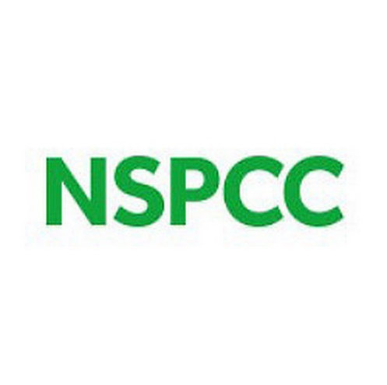](https://www.nspcc.org.uk/keeping-children-safe/online-safety/)

**Under 13**

Where can you get help if you think something wrong is happening? The NSPCC button has help on it. Click it!

1. Report it! Tell your school Designated Safeguarding Lead – get their advice.
2. Report to the platform you have used
3. Report it by clicking the CEOP button

Some **Top Tips** from us:

* Follow the latest guidance from [www.ceop.police.uk/safety-centre/](http://www.ceop.police.uk/safety-centre/)
* Make the link that you submit only viewable to people that you share it with
* Turn off comments
* Any videos should only contain the person that is entering the event (don’t have brothers and sisters running around in the background!)
* Videos and pictures should be taken carefully. They shouldn’t be in bedrooms or anywhere inappropriate
* Everyone in the video should wear suitable clothing
* Language, conduct and behaviour within the video should be appropriate to the task
* Don’t have car registration plates, house numbers, street signs, school logos etc on display