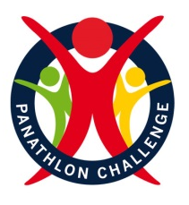
Primary Panathlon festival
Year Group

These challenges have been targeted at Year 1-6.
Where ?

Panathlon’s accessible range of multi-skills challenges for pupils with disabilities and special needs can be completed in the classroom or playground, and simultaneously by pupils in their own homes or gardens.

Challenges

This resource will provide you with guidance on how Panathlon activities can be delivered. There are 15 indoor games in this pack, including Boccia, Kurling & Tenpin activities, together with a scoring template. Why not test yourself and see how many you can complete?
How to get involved?

- Familiarise yourself with the Panathlon challenge.
- Set up the challenges.
- Allow the pupils to practice each challenge.
- Record the pupils final score for each challenge see if there is an improvement
- Submit your results to your teacher.
- Schools to complete monitoring form and send to SSP.

COVID-afety
Competition Leadership Award

Engage leaders by:
- Using leaders to lead part of the session (warm up).
- Using leaders to time the activities.
- Using leaders to deliver a cool down activity.
- Using leaders to record results.
- Using leaders to take photographs for use on social media to celebrate school involvement in the School Games.
- Using leaders to demonstrate tasks.
How to enter?

You can enter in 2 different ways
- Schools run these activities for key worker children in school and send in the results to SSP.
- Schools send resource to parents/ carers via home learning platform for pupils to take part at home. Parents/ carers submit pupils results to PE/ class teacher who collates results and sends to SSP.

Submit your monitoring forms to Laura Goodswen by Friday 19th March.

Rewards and Certificates
ipment Needed

There will be no official scoring for these challenges, but teachers should be awarding pupils for demonstrating the School Games values.

Schools will be sent a Panathlon UK participation certificate for each pupil that has taken part on receipt of the monitoring form which can be found on the website.

COVID-19 Safety

The South Norfolk SSP virtual multi skill challenges should be completed in accordance with your schools Covid-19 PE policy.

Safeguarding

During the South Norfolk SSP virtual multi skill challenges schools must adhere to their own school policy. Schools must follow their photo consent policy.
Risk Assessment

It is the responsibility of each school to assess the risk for participating in the challenges within their own school. It is the responsibility of schools to ensure that any space and equipment used is suitable for the challenge being attempted.

School Games Values

During each of the challenges pupils are challenged to demonstrate the School Games values;
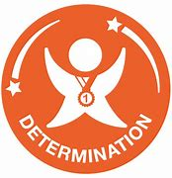
Determination is about the journey you go on to push yourself and achieve your dreams. Have the mental strength and self-discipline to overcome obstacles, commit to your goals and keep working every day to become the very best you can be. Don't hold back!

Giving it 100 percent. Putting your heart and soul into the game and never giving up. Passion makes you enter the race and passion makes you finish it.

Respect for the referee, for the opposition, for your teammates, for yourself and for the game. Accepting victory and defeat with grace, treating others politely and with understanding. Respect every day, for every sport and everyone.

Honesty with others and with yourself. Having the courage to do the right thing and what you know is right. Let the best person win, not the best cheat.

You've got to believe to achieve. Have the self-belief and confidence to succeed and reach your personal best.

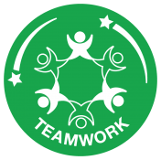
Treating everybody equally, supporting each other and working together to achieve at your very best level. Celebrate each other’s successes and be a positive team player.

