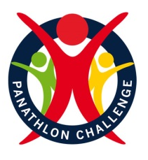

Panathlon Challenge at Home
Indoor Target Games
Thank you for taking part in the ‘Panathlon at Home’ challenges. There are 15 indoor games in this pack, including Boccia, Kurling & Tenpin activities, together with a scoring template.
Use these games as a guide. You may adapt the equipment and use whatever objects you’ve got at home. You can change the size of games to fit your space. Challenge yourself. Play for your personal best. Determine to improve on your own records. Involve family members and carers to collaborate and compete against.

Adaptations
Visually impaired players: A helper can clap to aid for direction to a target or assist with changes in direction.
Wheelchair users: Ramps can be used to help propel objects. If you don’t have a ramp, use a long piece of cardboard, change the distances or place the equipment off ground level, for example on a table, instead.

To receive a certificate please send your results to your class teacher who will forward the schools monitoring form to l.goodswen@fehs.set.education

Precision Bean Bag

Video Link - https://youtu.be/-_hmqisIGiU

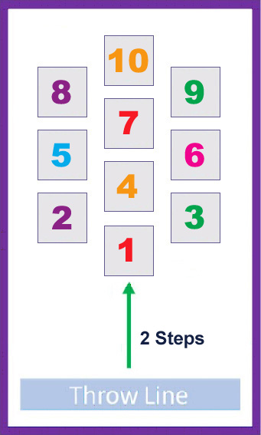
Equipment: 5 x Socks Rolled Up (Bean Bags, Soft Toys, Scrunched-Up Foil), 10 x A4 Paper with Numbers 1-10, Chair, Kitchen Timer (Stopwatch)

Aim: “Throw socks onto A4 papers with the highest numbers.”
- Throw 5 socks from a seated position 2 steps away from the numbered targets.
- The score is recorded from where the sock first lands, not its finishing position. And, if the sock finishes outside of the paper area all together, despite landing on a number, then the score is 0.
- Example: Bean bag hits 5, then slides off, score = 0.
- Example: Bean bag hits 5, then rests in between 8 and 7, score = 5.
- Only one score allowed per numbered target
e.g. three socks land on 6, scored as 6 points (not 18).

Scoring:
- Record the score from 5 thrown socks.
- Maximum score from 5 socks is: 10 + 9 + 8 + 7 + 6 = 40 points
- Timed: Total points based on 1 minutes play. Retrieve your own socks.
- High Score: 2 turns (10 attempts). How many can you score? Can you score the maximum of 80 points?
Variations Games:
- Maths Challenge: Choose a number between 15 and 40. Throw a maximum of five times to match the number. Expert Version: Do it without landing on the same number twice & using all 5 throws!
Into the Tower
Video Link – https://youtu.be/4pCM-tmeQlE
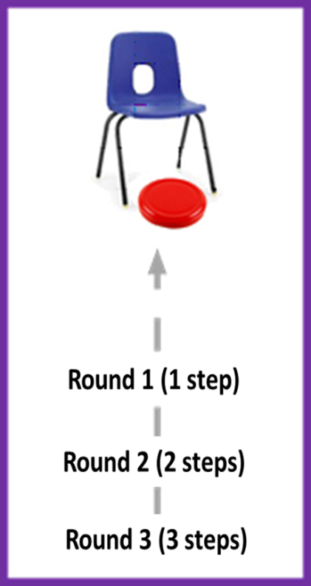
Equipment: 3 x Jam Jar Lids (Bean bags, Toy cars, rolled up socks), Chair (Cut out box), Kitchen Timer (Stopwatch).
Set up: This game requires a smooth floor that allows for pushing of objects to the chair and beyond.

Aim: “Push the ‘stone’ to stop underneath the tower.”
- Each turn has three pushes (attempts).
- Starting 1 step back from the chair, push the lid, to come to rest under the chair.
- If successful, move back another step.
- If you miss, stay at that distance.

Scoring:
- 1 point @ One steps back
- 2 points @ Two steps back
- 3 points @ Three steps back
- Maximum points per turn = 1 + 2 + 3 = 6 points.

- Timed: Total points based on 1 minutes play. Retrieve your own lids. Use a kitchen timer or stopwatch.
- High Score: Three turns (9 attempts). How many points can you score? Can you score the maximum of 18 points?

Variation Games:
- Can be played seated on a table, using a box with cut outs as the ‘tower’. Deduct 1 point if the lids falls off the table.
- Kurling Knockout Game. Place another lid under the chair. Push your lid to hit it, pushing it from under the chair. Replace the lid back under the chair once it’s been knocked out. Rules as above.

Funfair
Video Link - https://youtu.be/E76uthkCoJY
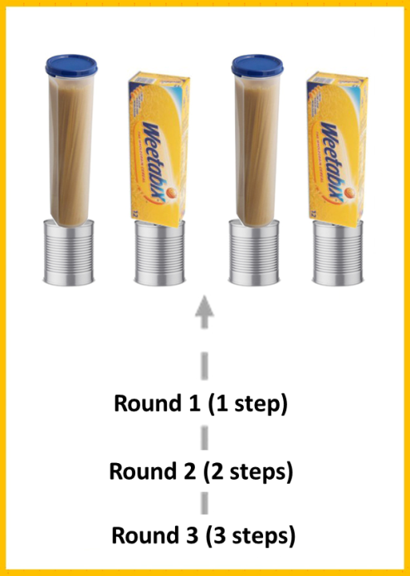
Equipment: 4 x Socks Rolled Up (bean bag, small ball), 4 x Tin Cans (plastic containers, other unbreakable items), 4 x Objects to stand on the tins (Boxes, Tupperware, Soft Toys), Kitchen Timer
Aim: “Throw to knock items off the tins.”
- 12 throws per turn.
- Round One - Throw 4 socks from one step back.
- Round Two - Throw 4 socks from two steps back.
- Round Three - Throw 4 socks from three steps back.
Scoring:
- 1 point - for each item knocked off in Round One.
- 2 points - for each item knocked off in Round Two.
- 3 points - for each item knocked off in Round Three.
- Maximum score per turn = 24 points.
4pts (round one) + 8pts (round two) + 12pts (round three).

- Timed: Total points based on 1 minutes play. Retrieve your own socks.
- High Score: 2 turns (12 + 12 throws). How many can you score? Can you get close to the maximum of 48 points?
Pirate Ship
Video Link - https://youtu.be/ieMVqynrp4Q

Equipment: 6 x Treasure Items (Rolled up socks, Board Game Counters, Soft Toys), 10 x A4 Paper with Numbers 1-10, Treasure Chest (Rug, sofa, chair), Stopwatch or Kitchen Timer
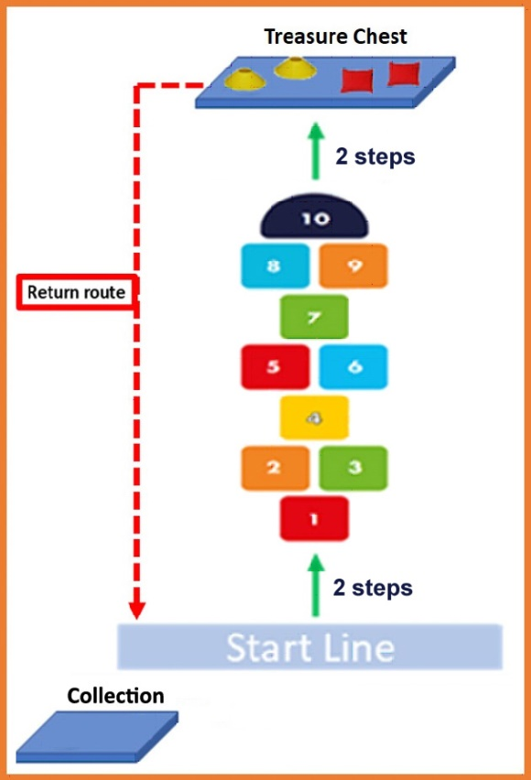
Set up: Can be done both indoors or outdoors (chalk on floor). If indoors, recommended on a non-slippery floor, or, a carpeted room.
Using A4 paper to show the hopscotch grid is optional. If you do use, can tape the paper to the floor. Consider wearing clean trainers too.
Aim: “Continuous Hopscotch to grab Treasure.”
- Hop & Jump your way to the ‘treasure’, take 1 item at a time back to the collection area behind the Start Line.
- Round One - Hop on numbers 1 – 4 – 7 – 10. Take 1 item. Return back to start line. Leave item in collection area.
- Round Two - Jumping two feet 2&3 - 5&6 - 8&9. Take 1 item. Leave item in collection area.
- Round Three – Full Hopscotch, alternating 1 foot to 2 feet on numbers: 1 – 2&3 – 4 – 5&6 – 7 – 8&9 – 10. Take 1 item. Leave item in collection area.
- Repeat, rounds 1 to 3, until all 6 items are collected (all 6 items must be in/on the collection area to finish).
Scoring:
- Timed: How long does it take you to collect all 6 items from the Treasure Chest & bring them back to the Collection area?

Adaptation:
- Wheelchair users: Complete alternate courses a shown in diagrams below.
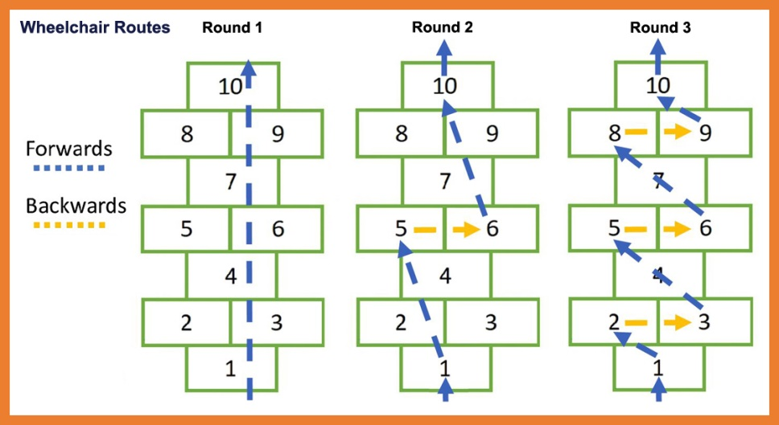

Boccia: The Game (Sock-ia)
Video Link – To come, in future update of this document
Equipment:
- 12 x Socks rolled up, of any 2 colours - 6 socks of each colour
- Tennis Ball as Target Ball (Other Ball or Household item like Tin Can, Upright Teddy)
- 2 x Chairs

Set-up: Clear a decent sized space. Place two chairs next to each other as the throwing line.

Aim: “Get as many socks closer to the target ball than the opponents.”
- First, a player rolls the target ball into play (into the cleared space). Retake if needed. If you are using a household item rather than a ball, place the item in play. See image (1) ‘Start of Game’.
- From a seated position, the same player aims for the target ball with their coloured sock.
- There is a particular rule on who throws next. It’s the player ‘not the closest’ to the target ball.
- In the below image (2) ‘During Game’ the red sock is the closest, so blue plays & continues to play until they are closer, or, they have no socks left (6 each). Once one player has no socks left, the other player plays out until all 12 socks have been thrown. Then the game is scored.
- If at any time you cannot tell who’s closer, alternate who throws next until you can tell who is closer.
- Collect up all socks after scoring the game. For the next game, alternate the player who throws the target ball & throws the first coloured sock.
(1) Start of Game – Target Ball in play (2) During Game - Blue throws next
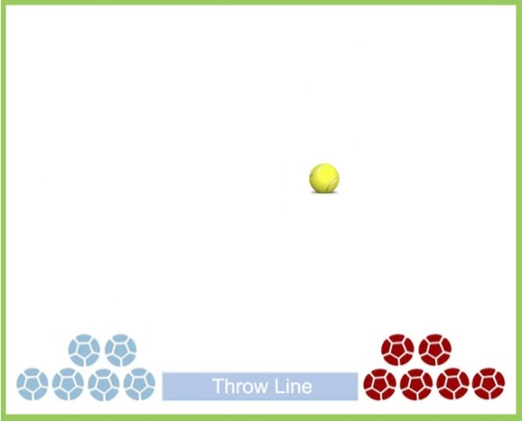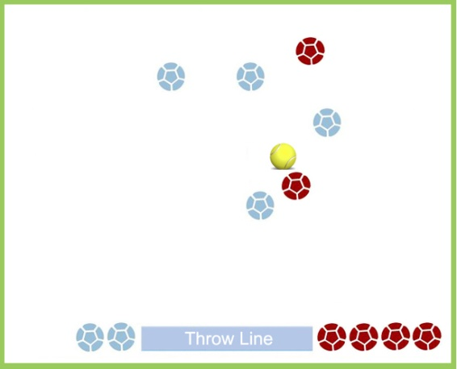

(3) End of Game – Score is 2 to Reds (3) Another End of Game - Score is 4 to Blues
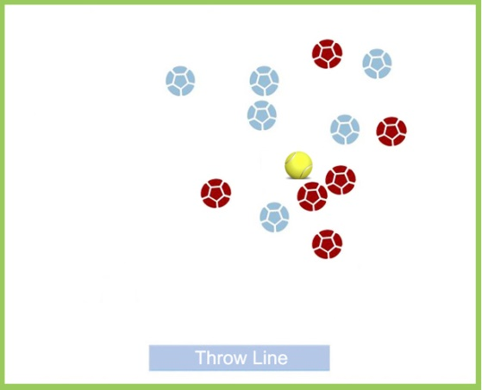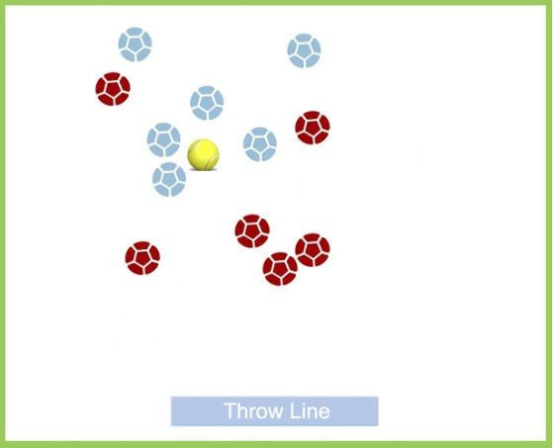

Scoring:
- A player receives one point for every sock closer to the target ball than the other players socks.
- Only one player gets points. There are only 6 possible scores: 1-0, 2-0, 3-0, 4-0, 5-0, 6-0.
- See ‘End of Game’ examples above. Red 2 – Blue 0 and Red 0 – Blue 4.
- Play 3 games. Add the points scored are across the games.
- Example Match:
  - 1st Game: Red 2 – Blue 0
  - 2nd Game: Red 1 – Blue 0
  - 3rd Game: Red 0 – Blue 4. Result: Blue’s win 4-3.
Competitive Variations
- Reducing Socks – Every time you win an individual game, you receive one sock less for the next game. The winner is the first player to have no socks left.

Practice Variations - Games to play on your own, with 6 socks.
- Place the target ball at different distances. Practice getting all 6 socks close to the target ball.
- Practice different types of throwing techniques: Underarm, Back of the hand underarm, Dart throw, Two handed chest push.
- Connection: How many socks can you throw to touch & rest against the target ball? Practice at different distances. If you have 6 balls of the same size (tennis balls), use balls instead of socks.
- Old News: Place one large piece of newspaper flat on the floor. Aim to get your sock (ball) on the paper. If you are successful, fold the paper in half, making the target smaller and continue until the paper is too small to fold. Alternatively, can use a kitchen dish cloth.

Noughts & Crosses
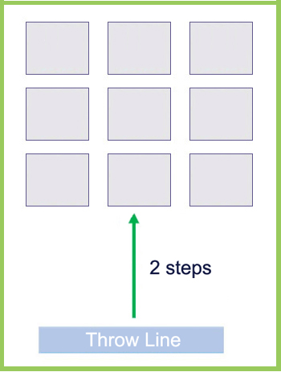
Video Link - https://youtu.be/mfbUcXhhPrQ
Equipment:
- 12 x Socks rolled up, of any 2 colours - 6 of each colour
(Bean Bags, Small Balls, Scrunched-Up Foil)
- 9 x A4 Paper at Targets (Small Hoops/Circles, Cloths/Flannels)
- Chair (2 Chairs for variation games)

Set-up: Place A4 Paper spaced out on the floor in a 3 x 3 pattern.
Aim: “Throw three socks to make a 3-in-a-row line.”
- From a seated position throw 9 socks of any colour.
- Socks must remain on the paper targets to count.
- Three-in-a-row lines can be horizontal, vertical or diagonal.
- After 9 throws, score and collect the socks.

Scoring:
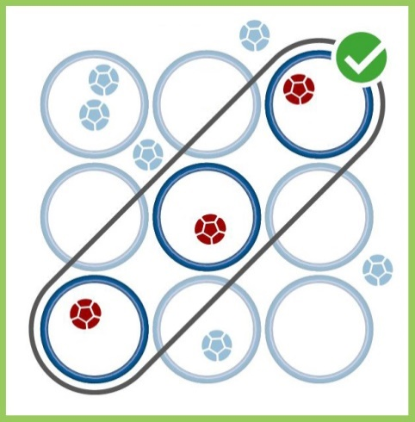
- High Score: How many three-in-a-row lines can you make from 2 turns (9 + 9 throws)? Remove all socks after the first turn.

Variations:
- Collaborative: With a family member in a second chair, alternate throwing to score as many three-in-a-row lines as possible, with 10 socks, 5 each. Score & collect after all 10 socks are thrown.
- Competitive: With a family member. Play against each other with 12 socks, 6 socks each of 2 different colours. Both players can have socks on the same paper target.
- Competitive - Classic ‘Noughts & Crosses’. Play against a family member with 10 socks: 5 socks each of 2 different colours. Once a paper target contains a sock, it belongs to that player. Remove any further socks that come to rest on an occupied target.
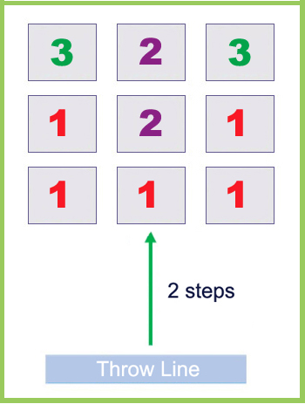
- Competitive Quickfire: As above, except don’t take it in turns to take a throw, when you’re ready to play, you play! If a sock comes to rest outside all the targets, forfeit that sock for the next game only.
The Grid variation

Set-up: Number the paper targets: 1,1,1 / 1,2,1 / 3,2,3 as per diagram.

Scoring:
- Continue playing ‘Three-in-a-Row’, with above rules.
- Gain points from landing on the paper targets, but only record them when you score a ‘Three-in-a-Row’ line.
- The back horizontal row is worth 8 points (3+2+3). The right side vertical row is worth 5 points (1+1+3). Diagonals are worth 6 points (1+2+3).
- Play on your own with 9 socks, or as a collaborative or competitive version.
- Additional competitive rules:
- Grab Back. Players are penalized if they throw a sock beyond the back of the grid (beyond the 3,2,3 papers). On the next throw, their opponent can choose to retrieve & replay one of their own socks (if they wish). They then have two throws in a row: (1) a retrieve & throw (2) followed by their throw in turn.
- Steal the space. If you land on a target that already contains an opponent’s sock, remove their sock. Continue until one player wins in the ‘Classic Noughts & Crosses’ game. If after 12 socks are thrown, the game is not yet won, players can choose to retrieve any of their own socks & players continue alternating turns.
Snooker Frame variation

Video Link – https://youtu.be/Wx1JI03CG8Q
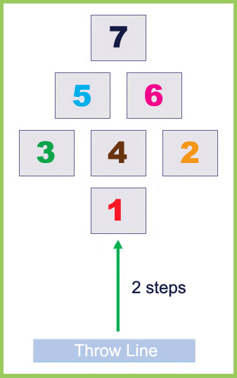
Set-up: Number the papers 1 to 7 with the snooker colours, as per diagram.

Aim: “Throw onto the Red and take a bonus shot.”
- Player aims for the red 1 at the beginning of each turn.
- If the sock comes to rest on the red 1, players can have a bonus shot at any number from 1 to 7. Aim for the Black 7 for a high score. After this attempt, the turn is over.
- If the player misses the first throw at the red 1, then their turn is over.

Scoring:
- Add the points as you play,
Red scores 1 point
Yellow scores 2 points
Green scores 3 points
Brown scores 4 points
Blue scores 5 points
Pink scores 6 points
Black scores 7 points
- High Score: How many points can you score with 6 turns?
Will be between 6 and 12 throws in total: 6 attempts at red + 6 bonus shots, if the red is hit on every turn.
Example score with 6 turns: 1 + Miss / Miss / 1 + 4 / 1 + 7 / Miss / 1 + 3 = Score of 18.

Variations
- Add ‘continue throwing your turn until you miss’ rule. Example: 1 + 4 + 1 + 6 + 1 + Miss = Score from that one turn is 13. Retrieve socks as you play.
- Change the Throw Line distance from Red 1 to make easier or more difficult.
- Move all the paper targets to different positions at the start of each game.

- Round the Table: The least amount of turns possible to ‘pot’ all the colours in order starting with Red.

- Collaborative: Play ‘Round the Table’ with another player, throwing alternately.
- Competitive: Play against another player. The first to 30 points wins. Then, add an extra rule – Player have to score exactly 30 points. They will need to aim for the correct colour as they approach 30.
- Competitive Shoot-Out: Quick Game. Rules as original game above (red 1 + bonus shot only per turn). When a colour (2,3,4,5,6,7) has been landed on, remove that paper target for the remainder of that game. Finish when only the Red 1 remains.

Close Move
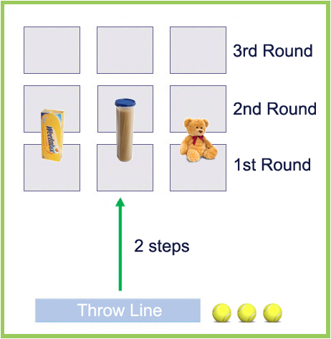
Video Link – To come, in future update of this document
Equipment:
- 3 x Small Balls (Bean Bags)
- 9 x A4 Paper as Targets
- 3 x Household items. Choose unbreakable items ie, no glass.
- Chair (2 Chair’s for variation games)

Set-up: Place A4 paper targets spaced out on floor in a 3 x 3 pattern.
At the start of the game, place the 3 household items on the closest 3 targets – position the items close the far edge of the targets.
Aim: “Roll the ball on the targets without touching the Household item.”
- From a seated position, the player aims for the paper targets with the household item on, without touching the household item.
- Roll 3 balls per round.
- Each game contains 3 rounds.
  - Round 1 - Aim to land a ball on each of the targets on the closest row..
  - Round 2 - Aim to land a ball on each of the targets on the middle row.
  - Round 3 - Aim to land a ball on each of the targets on the furthest row.
- After each round: Collect the balls and move the household items back to the next row of targets.

Scoring:
- Score 1 point for each time the ball comes to rest on the target without hitting the household item.
- If the ball touches the household item, no points for that roll.
- One score per target, ie, 2 balls on the same target is only 1 point.
- High Score: Best score from 2 games (9 + 9 throws).

Variations:
- Starter version: Play the three rounds without the household items on the targets.
- Change the distance of the Throw Line to the targets to make it easier or more difficult.
- Change the household items: smaller or larger to make it easier or more difficult. Move the position of the item on the target, which position is hardest?

Push Back variation
Video Link – To come, in future update of this document

Additional Equipment: Collection area (rug, sofa, basket), Kitchen Timer (stopwatch)
Aim: “Collect all the items from the grid in the least number of rolls”
- From a seated position the player rolls three balls at the three targets that have household items on them.
- Move an item directly back to the next row ONLY if you were successful.
- During the game an item will move from the nearest row through the middle row to the furthest row. Once a successful roll is completed at the target on the furthest row the item is taken off the grid and put into a collection area – continue until all the items are in the collection area.
- See the diagrams below.

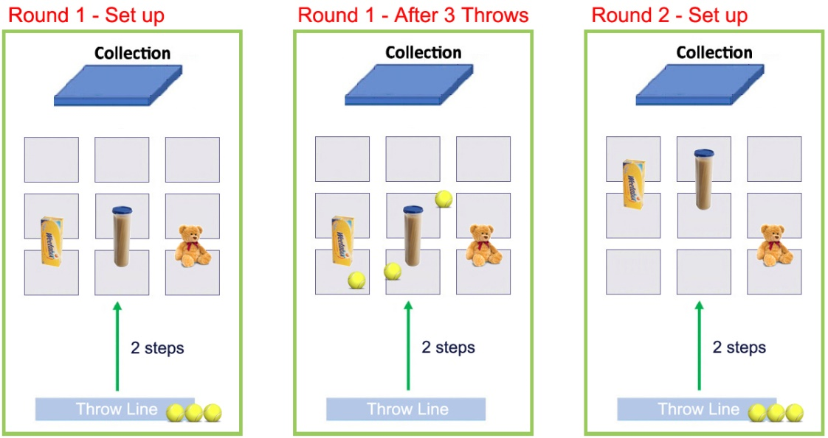

Scoring:
- Score: Record the lowest number of rolls to get the three items into the collection area.
- Timed: Time it takes to get all items into the Collection area.
- Time Trail: Total points based on 1 minute play. 1 point for every household item moved. Reset the item onto the nearest row against if it’s moved through the three rows.

Variations:
- Collaborative: Play with a family member. Take turns with 3 rolls each.
- Competitive: Play with a family member. Take turns with 3 throws each. Score 1 point each time you land on a target and “push back” an item. Continue until all the items are in the collection area.

Basket Flip It
Video Link – To come, in future update of this document
Equipment:
- 12 x Socks rolled up, of any 2 colours - 6 of each colour
- 2 x Baskets (Hoops)
- 2 x Chairs
- 1 x Finish Line: Cord, Book, Rug edge.

Set-up: Place 2 baskets close to each other (almost touching), 5 “movements” (basket widths) away from a finish line. See the diagram below.

Aim: “Throw a sock into the basket to move it towards the finish line.”
- 2 player game. Choose a target basket each.
- From a seated position, the player aims a sock to land in their own basket.
- Move the basket that the sock ends up in, one basket width towards the finish line.
- Try not to throw into your opponents basket! If you do, move it toward the finish line.
- Continue until one basket reaches the finish line. Collect the socks back during a game, if needed.

Start of Game During Play, after 9 throws
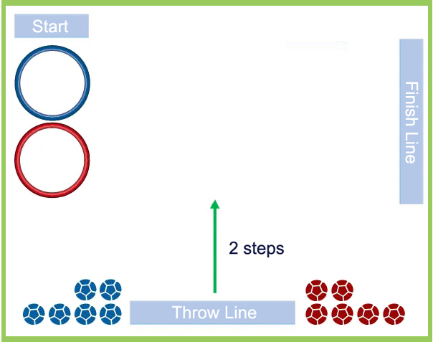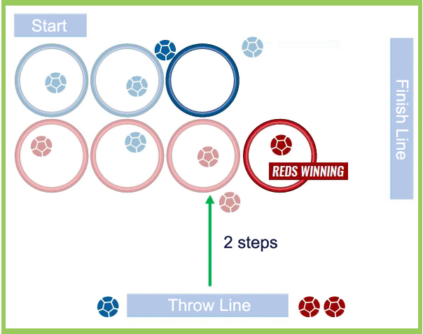

Variations:
- Vary the distance of the baskets from the Throwing Line to make easier or more difficult.
- Change the pattern of basket movement to moving away straight or moving away diagonally across.

- Solo Game: How many throws does it take to move the furthest basket 5 steps? Go back one step if the throw lands in the nearer basket.
- Dunk It! solo: Aim for one basket. What is the quickest time you can land a sock in the basket five times? + 1 second penalty for each miss. Retrieve your socks & continue.
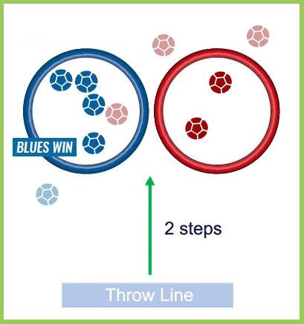
- Scatter Bugs version: Same game as above but remove the chair and scatter the socks around the room. Throw from different places aiming for the basket. Choose a suitable room to play this in.

- Dunk it! competition: Place 2 baskets close to each other (almost touching). 2 players. 6 throws each. Alternate the throws one throw at a time. Who can get the most socks in their basket? Land in your opponents basket, they gain a bonus point.
Variation Games Continued:
- It’s a Knock-Out:
  - Replace the 2 baskets with 2 pieces of paper, as the targets.
  - Place 2 socks on each target at the start of each game.
  - 2 player game. Throw the remaining four socks alternately, one at a time.
  - Play an attacking shot by knocking out the other players socks from their target. Or play a defensive shot, by throwing a sock onto your target.
  - Win by having more socks on your target than your opponent at the end of the game.

Game Set up Finished. Red Win
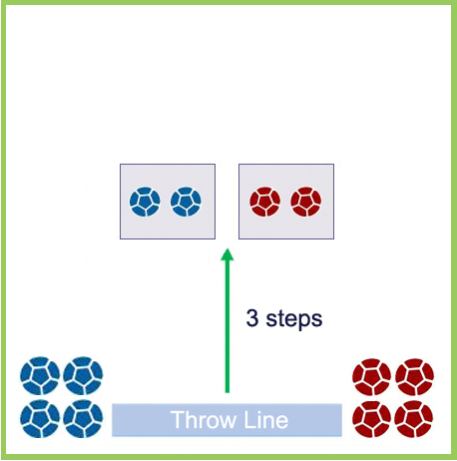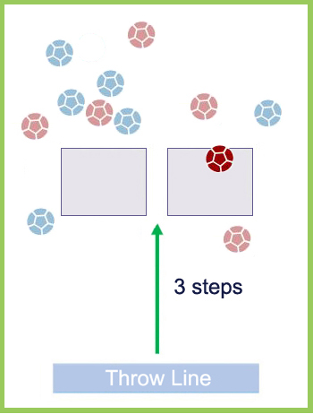

- Push Baskets:
  - 2 player game.
  - Place 7 pieces of paper in a semi-circle in front of a throwing line.
  - Start the game with the baskets placed on the outer pieces of paper, one at each end.
  - Alternate the throws.
  - When a player throws a sock into their basket, it is moved one space towards the other end of the semi-circle.
  - When the baskets meet, they “push” each other. After throwing a sock into your basket, move both baskets towards your opponent’s start position. If you throw into your opponents basket, move it towards your start position.
  - The winner is the player that pushes their opponent’s basket back to their original start position.
  - Collect the socks back if needed during a game.

Start of the Game End of the Game: Red Wins
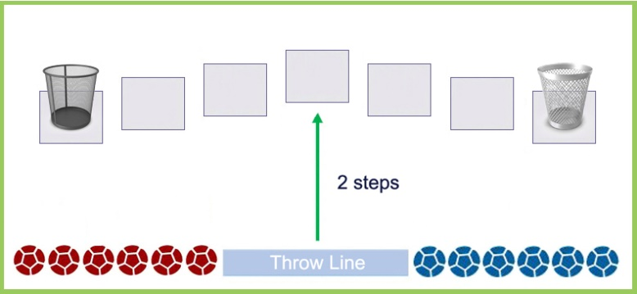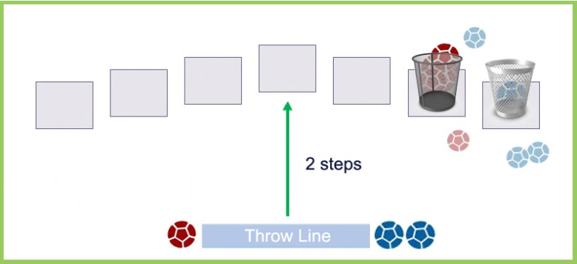

Through The Gap
Video Link – https://youtu.be/xVDdKzudjZQ
Equipment:
- 5 x Small Balls
- 6 x Household Items with straight(ish) sides (Skittles, Paper Cups)
- Tape Measure
- Marking Tape (6 small pieces of paper, 6 stickers placed on the floor underneath the items)
- Chair

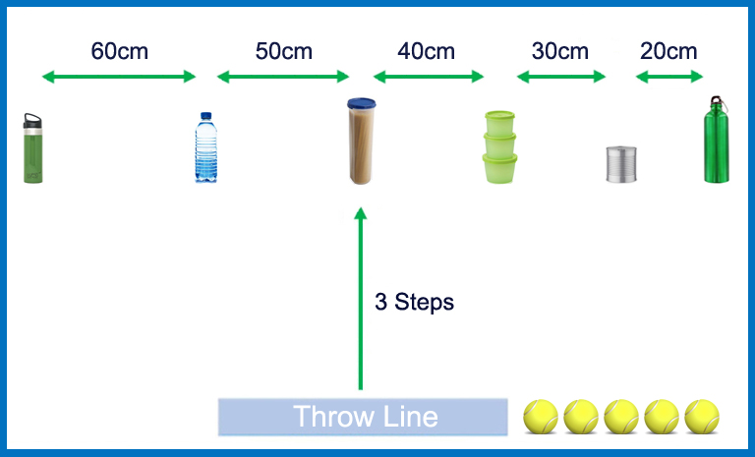
Set-up: Consider location, roll towards a wall or into soft furnishings. Use the tape measure to measure gaps between the items, from 20cm to 60cm. Consider using tape (or other) to mark where the items are placed. If you don’t want to measure it out, just create suitable decreasing gaps between the items.
Aim: “Roll a ball through the narrowing gaps.”
- Five rolls per turn.
- First, aim for the largest gap (60cm).
- If you succeed in rolling the ball through the gap between these items, move on to the next largest gap (50cm)
- If you fail to roll the ball through the gap, continue until you succeed.
- During a turn, if an item is knocked over, replace it back into position.
- At the start of teach turn, re-start at the largest gap.

Scoring:
- 1 point per successful roll. Only counts if the ball is rolled through the current gap aimed for.
- High Score: Best score from 2 turns (5 + 5 throws).

Variations:
- Change the distance between the Throw Line and the items to make it easier or harder.
- Change the distances between the items. To make the game easier start at 80cm to 40cms, or harder, change to 55cm to 15cms, for example.
- Change the order of narrowing gaps from left to right, to right to left.
- 2 Round Challenge: Continue the next round from where you left off in the previous round. If you scored 3 points in the first round, continue aiming for the 4th gap (30cm’s) at the start of the next game. Scoring: How many throws it takes to complete 2 full rounds?
- Goalball: Place a similar sized ball in front of each gap. Hit the ball with your ball to knock it through the gap (“goal!”). If you have limited balls, set up only 2 balls by the items at a time. How many attempts needed to score goals in all the gaps?
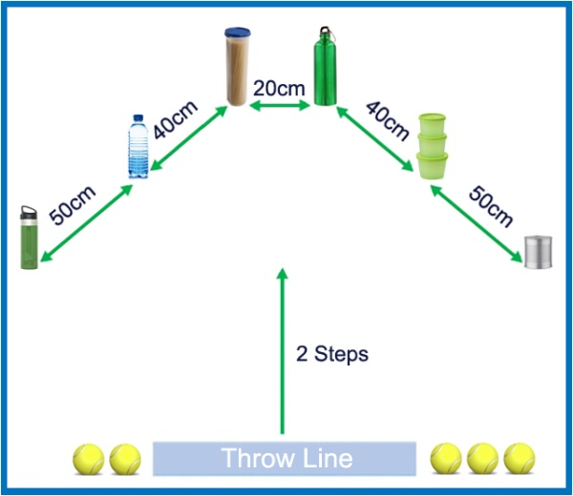
- Light Touch: Place a similar sized ball a few cm’s in front of each item. Roll your ball to hit the ball to push that ball onto the household item – without knocking it over.

- Pyramid Gaps: Move the household items into a pyramid (or tree) shape. Roll towards the larger gaps on the sides first, then aim for the central 20cm gap on your fifth roll.
- Pyramid Gaps - Competitive Game: Against a family member. 2 chairs. Pick a side (of items). Alternate the throws. Aim for outside 50cm gap first, then 40cm gap. Winner is the first through the 20cm gap.

10Pin
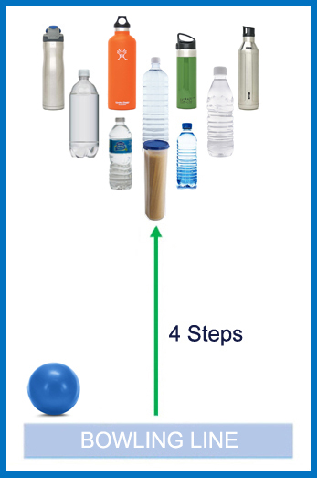
Video Clip - To come, in future update of this document
Equipment:
- Ball (Small to Medium size)
- 10 x non-breakable Household Items with straight(ish) sides (Skittles, Paper Cups, Plastic Bottles)
- Tape Measure
- Markers (10 small pieces of paper or stickers, to be placed on the floor underneath the items to allow for a quicker reset)

Set-up: Best played in a corridor. Tall & light household items will work best. Add a small amount of water to empty bottles, with closed tops. Consider playing this game outside on a smooth hard surface, if it is unsuitable to play inside.

Aim: “Knock down as many pins every turn.”
- 2+ players.
- Players take 2 consecutive bowls, from behind the line.
- After the first bowl, any knocked over pins are removed, leaving the remaining for the second bowl.
- If a strike is scored (all the pins knocked down) on the first bowl, all pins are then replaced for the player’s second bowl.
- Each player has 5 turns (10 bowls) each.

Scoring:
- 1 point is awarded for every pin knocked over.
- Strike - If all 10 pins are knocked over in the first bowl, 5 extra points are awarded = Total 15pts.
The pins are reset and the points from the second delivery are added (even another strike!).
- Spare - If the remaining pins are knocked down on the second bowl, 2 extra points are awarded = Total 12pts.

Variations:
- High Score (as solo): Highest score from 5 turns (10 bowls).

Panathlon at Home - Multi-Skills Scores
My Name: ______________________________

Game: | Player 1  Best Scores/Times | Player 2 (for competitive games)  Best Scores/Times
Please return this form to your class teacher
Panathlon at Home - 10-Pin Scoring (Template)

Name | 1 |  | 2 |  | 3 |  | 4 |  | 5 |  | Sub Total | Total Strikes  (5 extra pts, each) | Total Spares  (2 extra pts, each) | Overall Score

Name | 1 |  | 2 |  | 3 |  | 4 |  | 5 |  | Sub Total | Total Strikes  (5 extra pts, each) | Total Spares  (2 extra pts, each) | Overall Score

Please return this form to your class teacher

