Primary Personal Challenge
Who for ?

Year 1/2/3/4/5/6 classes.
Where ?

- Indoors (school hall)
- Outdoors (Playground or field)
- At home

Challenges

A fun ‘compete against yourself’ approach to physical activity with a focus on resilience and perseverance and the aim to achieve a bronze, silver and gold medal.

Four Primary Challenges are:
- Bean Bag Throw
- Catch and Clap
- Tap up Tennis
- Super Slalom Run

Equipment Needed

- Stopwatch
- Bean Bags
- Hoops
- Balls
- Tennis Racket
- Cones
If you do not have the equipment listed above as you are taking part at home, please adapt activities using items you can find in your home.
How to get involved?

- Familiarise yourself with the challenge.
- Set up the challenges.
- Record the pupils first attempt.
- Allow the pupils to practice each challenge.
- Record the pupils final attempt for each challenge see if there is an improvement.
- Submit your results to your teacher.
- Schools to complete monitoring form and send to SSP.

COVID-19 Safety
Competition Leadership Award

Engage leaders by:
- Using leaders to lead part of the session (warm up).
- Using leaders to time the activities.
- Using leaders to deliver a cool down activity.
- Using leaders to record results.
- Using leaders to take photographs for use on social media to celebrate school involvement in the School Games. Permission will be required.
- Using leaders to demonstrate tasks.

How to enter?

You can enter in 2 different ways
- Schools run these activities for key worker children in school and send in the results to SSP.
- Schools send resource to parents/ carers via home learning platform for pupils to take part at home. Parents/ carers submit pupils results to PE/ class teacher who collates results and sends to SSP.

Submit your monitoring forms to Laura Goodswen by Friday 19th March.
uipment Needed
Rewards and Certificates

There will be no official scoring for these challenges, but teachers should be awarding pupils for demonstrating the School Games values.

Schools will be sent a participation certificate for each pupil that has taken part on receipt of the monitoring form which can be found on the website.

COVID-19 Safety

The South Norfolk SSP virtual personal challenges should be completed in accordance with your schools Covid-19 PE policy.

Safeguarding

During the South Norfolk SSP virtual personal challenges schools must adhere to their own school policy. Schools must follow their photo consent policy.
Risk Assessment

It is the responsibility of each school to assess the risk for participating in the challenges within their own school. It is the responsibility of schools to ensure that any space and equipment used is suitable for the challenge being attempted.

School Games Values

During each of the challenges pupils are challenged to demonstrate the School Games values;
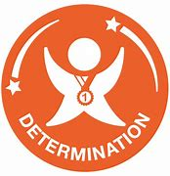
Determination is about the journey you go on to push yourself and achieve your dreams. Have the mental strength and self-discipline to overcome obstacles, commit to your goals and keep working every day to become the very best you can be. Don't hold back!

Giving it 100 percent. Putting your heart and soul into the game and never giving up. Passion makes you enter the race and passion makes you finish it.

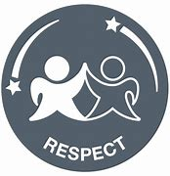
Respect for the referee, for the opposition, for your teammates, for yourself and for the game. Accepting victory and defeat with grace, treating others politely and with understanding. Respect every day, for every sport and everyone.

Honesty with others and with yourself. Having the courage to do the right thing and what you know is right. Let the best person win, not the best cheat.

You've got to believe to achieve. Have the self-belief and confidence to succeed and reach your personal best.

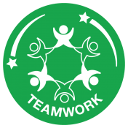
Treating everybody equally, supporting each other and working together to achieve at your very best level. Celebrate each other’s successes and be a positive team player.

Challenge one- Bean Bag Throw

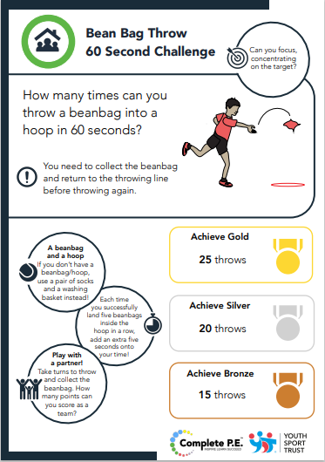

Instructions
- Stand 2m away from your hoop.
- See how many times your bean bag can land inside the hoop?
- Score 1 point each time your bean bag lands inside the hoop.
- You will have to collect your bean bag after each throw.

How to Score
- Record pupils first attempt at the challenge.
- Allow pupils time to practice the skill
- Record pupils second attempt to see if they have achieved a personal best.
- Schools- how many pupils achieved a bronze, silver or gold medal for Bean Bag Throw?

Challenge Two- Catch and Clap

Challenge Two- Catch and Clap
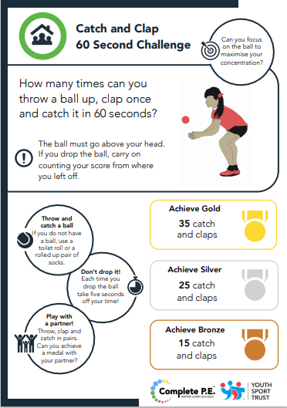

Instructions
- Make sure you are standing in a space.
- The ball must go above your head to count.
- If the ball is dropped, carry on counting your score from where you left off.
- Maybe practise this challenge with a partner.

How to Score
- Record pupils first attempt at the challenge.
- Allow pupils time to practice the skill
- Record pupils second attempt to see if they have achieved a personal best.
- Schools- How many pupils achieved a bronze, silver or gold medal for catch and clap?

Challenge Three- Tap up Tennis

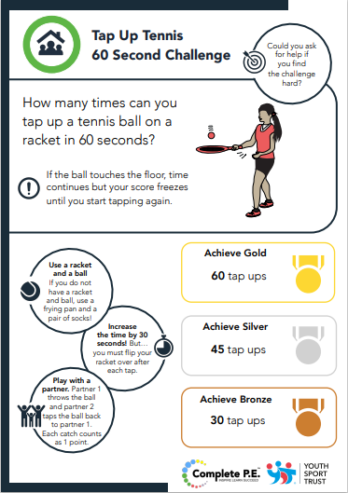

Instructions
- Collect a ball, tennis racket and stand in a space.
- See how many times you can tap your tennis ball up and down on your racket?
- If the ball touches the floor, time continues but your score freezes until you start tapping again.

How to Score
- Record pupils first attempt at the challenge.
- Allow pupils time to practice the skill
- Record pupils second attempt to see if they have achieved a personal best.
- Schools- How many pupils achieved a bronze, silver or gold medal for Tap up Tennis?

Challenge Four- Super slalom Run

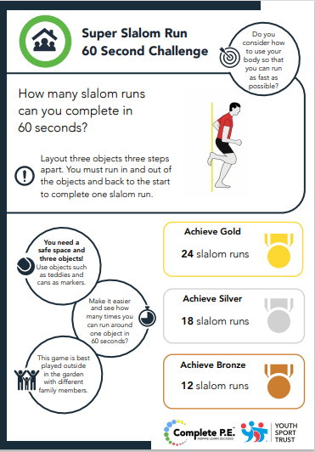

Instructions
- Layout three objects in a straight line covering a total distance of 7.5m
- You must run in and out of the objects ad back to the start to complete 1 slalom run.
How to Score
- Record pupils first attempt at the challenge.
- Allow pupils time to practice the skill
- Record pupils second attempt to see if they have achieved a personal best.
- Schools- How many pupils achieved a bronze, silver or gold medal for Super Slalom Run?

Class Personal best Result Sheet
See if your pupils achieved a personal best?

School Name…………………………………………………………………………………………
Class Name………………………………………………Year Group......................................

 | Pupils Name | Bean Bag Throw |  |  | Catch and Clap |  |  | Tennis Tap Ups |  |  | Slalom Run
 |  | Bronze | Silver | Gold | Bronze | Silver | Gold | Bronze | Silver | Gold | Bronze | Silver | Gold
1
2
3
4
5
6
7
8
9
10
11
12
13
14
15
16
17
18
19
20
21
22
23
24
25
26
27
28
29
30
 | Total Number medals achieved
Pupil Result Sheet
Did you achieve a personal best?

Pupil Name………………………………………………Year Group......................................

Place your first attempt score in the Bronze, Silver or Gold box. Once you have practised record your final score and see if you have achieved a personal best.

 | Bean Bag Throw |  |  | Catch and Clap |  |  | Tennis Tap Ups |  |  | Slalom Run
 | Bronze | Silver | Gold | Bronze | Silver | Gold | Bronze | Silver | Gold | Bronze | Silver | Gold
First Attempt
Personal Best

Please return to your class teacher

