Learning & Discovery Festival

**DATE 28th February 2022**

**9.30-11.30pm & 12.30-2.30pm**

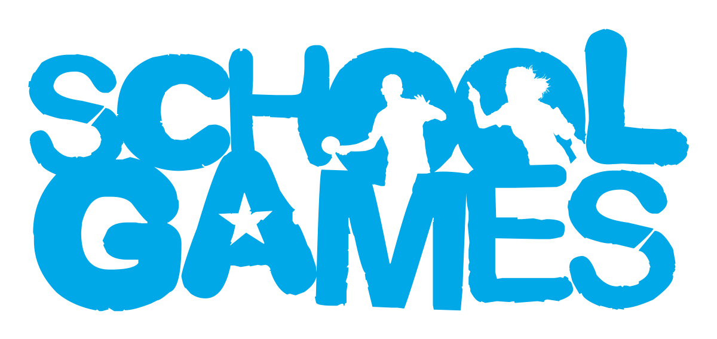

**VALUES**

**During School Sport Partnership experiences pupils are challenged to demonstrate the School Games values.**

Target Audience

These events are non-competitive and focus on targeting pupils who would benefit from being more physically active.

Year groups

Year 5 & 6

venue

Long Stratton Leisure Centre, NR15 2UY

Intent

Widening the competition environment to develop health.

Leadership Opportunities

**Engage Primary leaders by:**

* Using leaders to lead your event (warm up/cool down).
* Using leaders to demonstrate tasks in pre-event practice.
* Using leaders to record match day results.
* Using leaders to take photographs for use on social media to celebrate school involvement in the School Games.

How to Enter

This is an open entry event open to all schools in South Norfolk SSP. Please enter via the SSP website [www.southnorfolkssp.co.uk](http://www.southnorfolkssp.co.uk) or contact L Goodswen [l.goodswen@fehs.set.education](mailto:l.goodswen@fehs.set.education)

**Determination –** Determination is about the journey you go on to achieve your goals.

**Passion-** Giving it 100%, putting your heart and soul into the game and never giving up.

**Respect-** For the referee, for the opposition, for your teammates and for yourself.  Treating others politely and with understanding.

**Honesty-** Honesty with others and with yourself.  Having the courage to do the right thing what you know is right.

**Self-Belief-** Have the self-belief and confidence in yourself to succeed and reach your personal best.

**Teamwork-** Treating everyone equally, supporting each other and working together to have fun and achieve at your very best level.

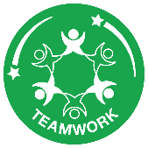



What is the L&D Festival-Event information

* The Learning and Discovery festival is part of the inclusion 2020 project set up by the Youth Sport Trust (YST), which focuses on inspiring pupils- with or without SEND- to play and enjoy unified sport together, and challenges attitudes and perceptions of disabilities.
* Each event will be made up of 5 stations
* 4 x inclusive sport stations each of the inclusive sport stations will be based upon adapted versions of Paralympic sports. These will be Athletics, Badminton, New Age Kurling, Seated Volleyball.
* 1x Breakout station which provides a more informal opportunity for the young people to work on skills, engage in informal play and form new friendships.
* The L&D festival will feature 6 teams across the session competing in the activities stated above.
* Once the first 3 rotations have been completed, then a short break, then 2 more rotations.
* After the event pupils will have the opportunity to self-reflect on the festival to find out what they learned from the day and what they will take away because of attending.
* Good sportsmanship will be expected from all players, staff, and spectators.
* **Unfortunately, we are unable to accommodate parent spectators at this event.**

Outcomes of the L&D Festival

* **Raising aspiration** of young people with additional support needs and those that support them to realise their potential in and through physical education and sport.
* **Inspiration:** providing opportunities to participate in new inclusive activity, encouraging lifelong participation.
* **Increasing the number, range, and quality** of opportunities for ALL young people to participate and progress in PE, School Sport and School Games.

Team Size

* Schools invited to bring a maximum of 10 pupils in year 5-6
* More may be allowed if numbers are low.

Equipment

* Please ensure pupils are dressed in suitable indoor PE kit and bring a water bottle.
* Hair should be tied back, and jewellery removed.

Certificates

All schools will be sent a participation certificate for each pupil that has taken part in the Learning and Discovery Festival. Schools will also be provided with sportsmanship award certificates for pupils who have demonstrated any of the School Games Values.

Further Opportunities

Frees resources for teachers: YST Top Sportsability please contact Laura for the County Access Code.