Mini Tennis/ Multi Skills

**DATE 10th March 2022**

**9.30-11.30am & 12.30-2.30pm**

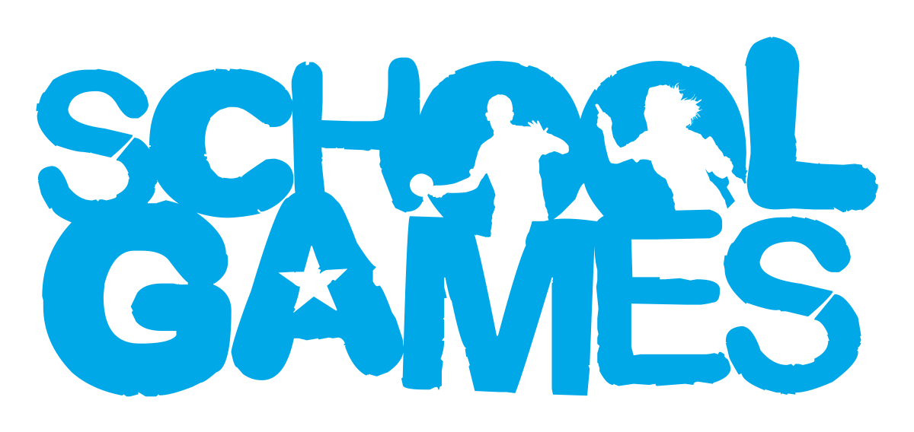

**VALUES**

**During School Sport Partnership experiences pupils are challenged to demonstrate the School Games values.**

Target Audience

These events are for pupils who enjoy friendly competition but don’t want to solely focus on winning and losing, instead they include a focus on the School Games Values.

Year groups

Year 3&4

venue

Easton College Tennis Centre, NR9 5DX.

Intent

To support individual development in sport.

Reframing Competition

The Mini Tennis festival will provide opportunities for ALL young people to develop fundamental movement skills. The sessions will challenge young people to achieve their personal best.

Leadership Opportunities

**Engage Primary leaders by:**

* Using leaders to act as ‘Spirit Captains’ to lead discussions with young people.
* Using leaders to lead your event (warm up/cool down).
* Using leaders to demonstrate tasks in pre-event practice.
* Using leaders to record match day results.
* Using leaders to take photographs for use on social media to celebrate school involvement in the School Games.

How to Enter

This is an open entry event open to all schools in South Norfolk SSP. Please enter via the SSP website [www.southnorfolkssp.co.uk](http://www.southnorfolkssp.co.uk) or contact L Goodswen [l.goodswen@fehs.set.education](mailto:l.goodswen@fehs.set.education)

**Determination –** Determination is about the journey you go on to achieve your goals.

**Passion-** Giving it 100%, putting your heart and soul into the game and never giving up.

**Respect-** For the referee, for the opposition, for your teammates and for yourself.  Treating others politely and with understanding.

**Honesty-** Honesty with others and with yourself.  Having the courage to do the right thing what you know is right.

**Self-Belief-** Have the self-belief and confidence in yourself to succeed and reach your personal best.

**Teamwork-** Treating everyone equally, supporting each other and working together to have fun and achieve at your very best level.





Event information

* An inclusive engaging and challenging event for primary schools in South Norfolk.
* The primary tennis skills festival will build on core fundamental tennis-based skills (body movement, balance, reaction time, hand/racket coordination).
* The challenges in the festival are designed to build confidence of the pupils in a fun and motivational way.
* Schools may bring 20 pupils from year 3-4.
* More pupils may be allowed if numbers are low.
* Pupils will get chance to take part in 8 skill challenges with 2 stations off which allow for a short water/ toilet break.
* Good sportsmanship will be expected from all players, staff, and spectators.
* **Unfortunately, we are unable to accommodate parent spectators at this event.**

Equipment

Schools must bring their own

* Tennis Rackets
* Hair should be tied back, and jewellery removed.

Certificates

All schools will be sent a participation certificate for each pupil that has taken part in the Mini Tennis/ Multi Skills event.

Schools will also be provided with sportsmanship award certificates for pupils who have demonstrated any of the **School Games Values.** Pupils selected for these awards will be asked to stand up at the end of the event to be celebrated.

Further Opportunities

**If your school have enjoyed the Mini Tennis experience, there may be an opportunity to attend the LTA County Competition event. Further details will follow.**