Quicksticks Hockey

**DATE 23rd March 2022**

**10am-2pm**

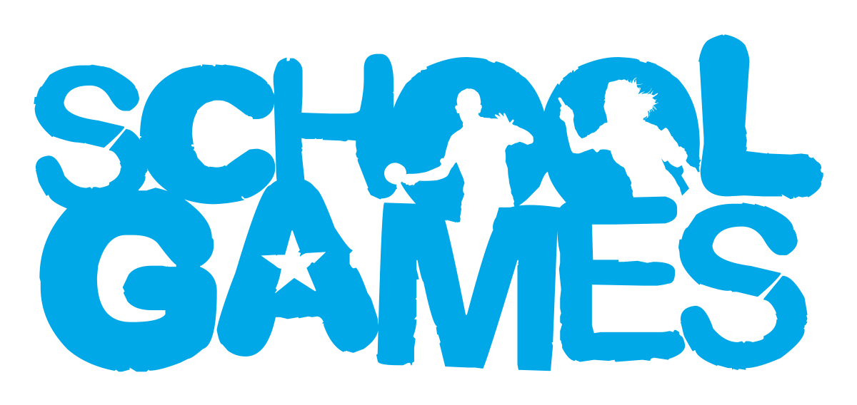

**VALUES**

**During School Sport Partnership experiences pupils are challenged to demonstrate the School Games values.**

Target Audience

These events are for pupils who enjoy friendly competition but don’t want to solely focus on winning and losing, instead they include a focus on the School Games Values.

Year groups

Year 3&4

venue

Harleston Magpies Hockey Club, IP21 5UF

Intent

To develop different sport skills.

Reframing Competition

Skills Challenges- Schools will be given 2 pre-event challenge to practice before the event. See details below.

Leadership Opportunities

**Engage Primary leaders by:**

* Using leaders to act as ‘Spirit Captains’ to lead discussions with young people.
* Using leaders to lead your event (warm up/cool down).
* Using leaders to demonstrate tasks in pre-event practice.
* Using leaders to record match day results.
* Using leaders to take photographs for use on social media to celebrate school involvement in the School Games.

How to Enter

This is an open entry event open to all schools in South Norfolk SSP. Please enter via the SSP website [www.southnorfolkssp.co.uk](http://www.southnorfolkssp.co.uk) or contact L Goodswen [l.goodswen@fehs.set.education](mailto:l.goodswen@fehs.set.education)

**Determination –** Determination is about the journey you go on to achieve your goals.

**Passion-** Giving it 100%, putting your heart and soul into the game and never giving up.

**Respect-** For the referee, for the opposition, for your teammates and for yourself.  Treating others politely and with understanding.

**Honesty-** Honesty with others and with yourself.  Having the courage to do the right thing what you know is right.

**Self-Belief-** Have the self-belief and confidence in yourself to succeed and reach your personal best.

**Teamwork-** Treating everyone equally, supporting each other and working together to have fun and achieve at your very best level.





Challenges

**Team Passing-** Total number of passes in 1 minute

In the team of 5 pupils must pass the ball to each other across a channel diagonally, the passes must be 6m apart. When the last player gets the ball, the team will then repeat the activity in reverse.

**Team Shooting-** Total number of goals in 1 minute

In the team of 5 pupils must score as many goals as possible 4 meters out from the goal, they are only allowed 1 ball and must use 1 player as a collector, ensuring the roles are rotated after each shot.

**We will then combine school teams shooting and passing score to create an overall score.**

Format

* Schools will complete their team challenges during the first phase of the event.
* The school team who achieves the top scores in this section will be rewarded at the end of the event.

Matches

* In the afternoon schools will be split into 4 teams of 5 pupils.
* Then will play fixtures against others in their groups, focussing on implementing their sport specific skills rather than the outcome of the game.
* The winners of each group will be awarded with South Norfolk School Games T-shirts.

Event information

* Schools may bring 20 pupils from year 3-4. Please split into four teams should include 2 girls and 2 boys (where possible). Teams will be allocated Commonwealth Games team names prior to the event.
* More pupils may be allowed if numbers are low.
* The morning will consist of a skill-based carousel of hockey activities including the two challenges.
* During the afternoon teams will take part in fun round robin matches.
* Each round robin group will consist of 4 teams per pitch.
* All matches will be refereed by leaders/ volunteers. The referee’s decision is final.
* All matches will be approximately 8 continuous minutes (no half time).
* It is suggested that team managers rotate players to give players equal playing time.
* Good sportsmanship will be expected from all players, staff, and spectators.
* **Unfortunately, we are unable to accommodate parent spectators at this event.**

Equipment

Schools must bring their own

* Quicksticks Hockey Ball- 1 per team
* Quicksticks
* Bibs- different colours for each team
* Shin pads
* Gumshield
* Hair should be tied back, and jewellery removed.

Scoring

* Teams are awarded the following points depending on the outcome of the match (Win= 3 points, draw= 2 points, lose= 1 point).
* At the end of the group stage if there is a draw on points, goal difference will be used to separate teams followed by total number of goals scored and then the head-to-head result between the teams.

Certificates

The winning team of each round robin will receive a South Norfolk SSP School Games T-shirt and winner’s certificate. Schools will also be provided with sportsmanship award certificates for pupils who have demonstrated any of the **School Games Values.** Pupils selected for these awards will be asked to stand up at the end of the event to be celebrated.

The winning team in the challenges will be awarded medals.

All schools will be sent a participation certificate for each pupil that has taken part in the Quicksticks Hockey event.

Game Rules

**Team Size-** 4 a side game- TRY TO HAVE 2 BOYS AND 2 GIRLS ON THE PITCH AT ALL TIMES there are no goal keepers in Quicksticks.

**Fixtures**- will be centrally timed, play will start and stop when the bell sounds.

**Starting and restarting-**

* Start with a centre pass which can be passed in any direction.
* All players in their own half at each centre pass.

**Penalty Goal-**

* Awarded where a player deliberately uses feet or body to stop the ball crossing the goal line.

**Free Pass-**

* Given when an offence occurs.
* Taken from where the offence occurred.
* All opposition players stand 3m back.

**Free Pass Awarded When-**

* Ball passes over the sideline.
* Ball crosses over the back line off attacker- taken from front of the shooting circle
* Ball crosses back line off defender- taken from the corner.
* Kicks, picks up, carries the ball
* Attempts to play at a high ball (above knee height)
* Uses the round side of their stick
* Obstructs by running between the ball and an opponent thereby preventing opponent from playing the ball.
* Plays the ball dangerously high.
* Rough or dangerous play.