Dynamos Cricket

**DATE 15th June 2022**

**9.30am-2.30pm**

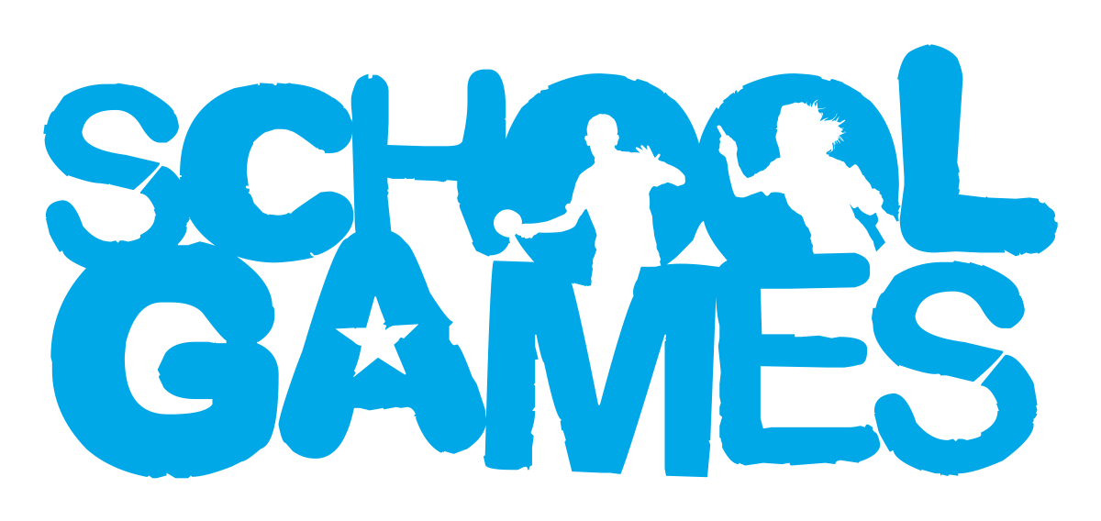

**VALUES**

**During School Sport Partnership experiences pupils are challenged to demonstrate the School Games values.**

Target Audience

These events are for pupils who are competitive in nature and enjoy performing and competing against others.

Year groups

Year 5-6

venue

[Hall Road, Great Melton, Norwich NR9 3BJ](https://www.bing.com/local?lid=YN1029x2947703927692726538&id=YN1029x2947703927692726538&q=Great+Melton+Cricket+Club&name=Great+Melton+Cricket+Club&cp=52.61276626586914%7e1.1526308059692383&ppois=52.61276626586914_1.1526308059692383_Great+Melton+Cricket+Club)

Intent

To develop character and life skills.

Leadership Opportunities

**Engage Primary leaders by:**

* Using leaders to act as ‘Spirit Captains’ to lead discussions with young people.
* Using leaders to lead your event (warm up/cool down).
* Using leaders to demonstrate tasks in pre-event practice.
* Using leaders to record match day results.
* Using leaders to take photographs for use on social media to celebrate school involvement in the School Games.

How to Enter

This is an open entry event open to all schools in South Norfolk SSP. Please enter via the SSP website [www.southnorfolkssp.co.uk](http://www.southnorfolkssp.co.uk) or contact L Goodswen [l.goodswen@fehs.set.education](mailto:l.goodswen@fehs.set.education)

**Determination –** Determination is about the journey you go on to achieve your goals.

**Passion-** Giving it 100%, putting your heart and soul into the game and never giving up.

**Respect-** For the referee, for the opposition, for your teammates and for yourself.  Treating others politely and with understanding.

**Honesty-** Honesty with others and with yourself.  Having the courage to do the right thing what you know is right.

**Self-Belief-** Have the self-belief and confidence in yourself to succeed and reach your personal best.

**Teamwork-** Treating everyone equally, supporting each other and working together to have fun and achieve at your very best level.

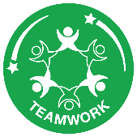



Rules

Dynamos Cricket provides a perfect introduction for all 8-11 year olds new to sport. It provides children with a more social offer in schools, an exciting game of countdown cricket.

Event Information

* All matches will be played in accordance to Dynamo Cricket Rules, which are available to download via <http://icoachcricketecb.co.uk/dashboard>
* Matches will be umpired by young leaders. The umpire’s decision is final.
* Each team comprises of 8 players. Squads are limited to 10 players.
* The two teams toss a coin to decide which team has the choice of either batting or fielding first.
* Each game shall consist of one innings per team.
* The batting side shall be divided into pairs.
* Players must rotate fielding positions.
* **Please note we will not be using the Free Hit Rule at this event.**
* Teams will be awarded the following points depending on the outcome of the match (Win = 3 points, Draw = 1 point, Loss = 0 points).
* Good sportsmanship will be expected from all players, staff and spectators.
* **Unfortunately, we are unable to accommodate parent spectators at this event.**

Equipment

* Please can all schools bring their own Cricket bats to the event.

Certificates

All schools will be sent a participation certificate for each pupil that has taken part in the Bee Netball event. Schools will also be provided with sportsmanship award certificates for pupils who have demonstrated one of the **School Games Values.**

The winning team will receive medals and certificates and the second and third placed teams will receive certificates.